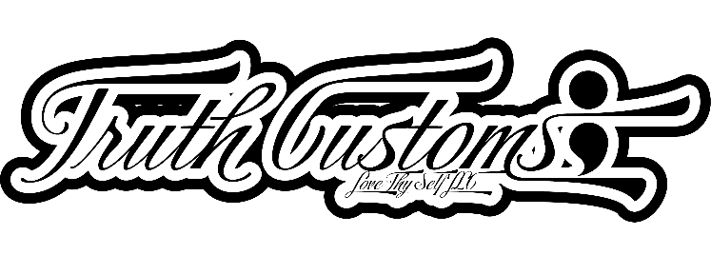
Date: _____________________

First Name: ___________________________________ Phone Number: _______________________
Last Name: ___________________________________ E-mail: ______________________________
When do you need the order? All custom orders require, at minimum, 15 days prior to requested date. Any time later will be charged an additional service fee. ___________________

How many shirts do you want in each size, color, location, and what you want the shirt to say? Only one print area is covered in your purchase, however, if you choose to have an additional print area (front and back), the second print area will be an additional fee.

Design 1
Size | Color | Location | Please specify what each side should  say | Number of shirts

Design 2
Size | Color | Location | Please specify what each side should  say | Number of shirts

Design 3
Size | Color | Location | Please specify what each side should  say | Number of shirts

Design 4
Size | Color | Location | Please specify what each side should  say | Number of shirts

Design 5
Size | Color | Location | Please specify what each side should  say | Number of shirts
Thank you for your interest in Truth Clothing! Please allow approximately 10 business days for your order to be fulfilled if you have an order for over 15 items. If you ordered more than the previously mentioned number, allow more time for fulfillment. Once your form has been processed, you will be sent an invoice with the total cost of your order. For work to begin, a 20% deposit is required that is non-refundable. If you agree with these terms, please sign and date below. Thank you for choosing Truth Clothing!

If there are any issues with your order you will be contacted with the details. If you have any questions or concerns, please contact us at
kennethyork@lovethyself.net or (312) 800-9083. Please allow up to 24 hours for a response. Email the complete form to the above-mentioned email address.

Signature______________________________ Date _______________

